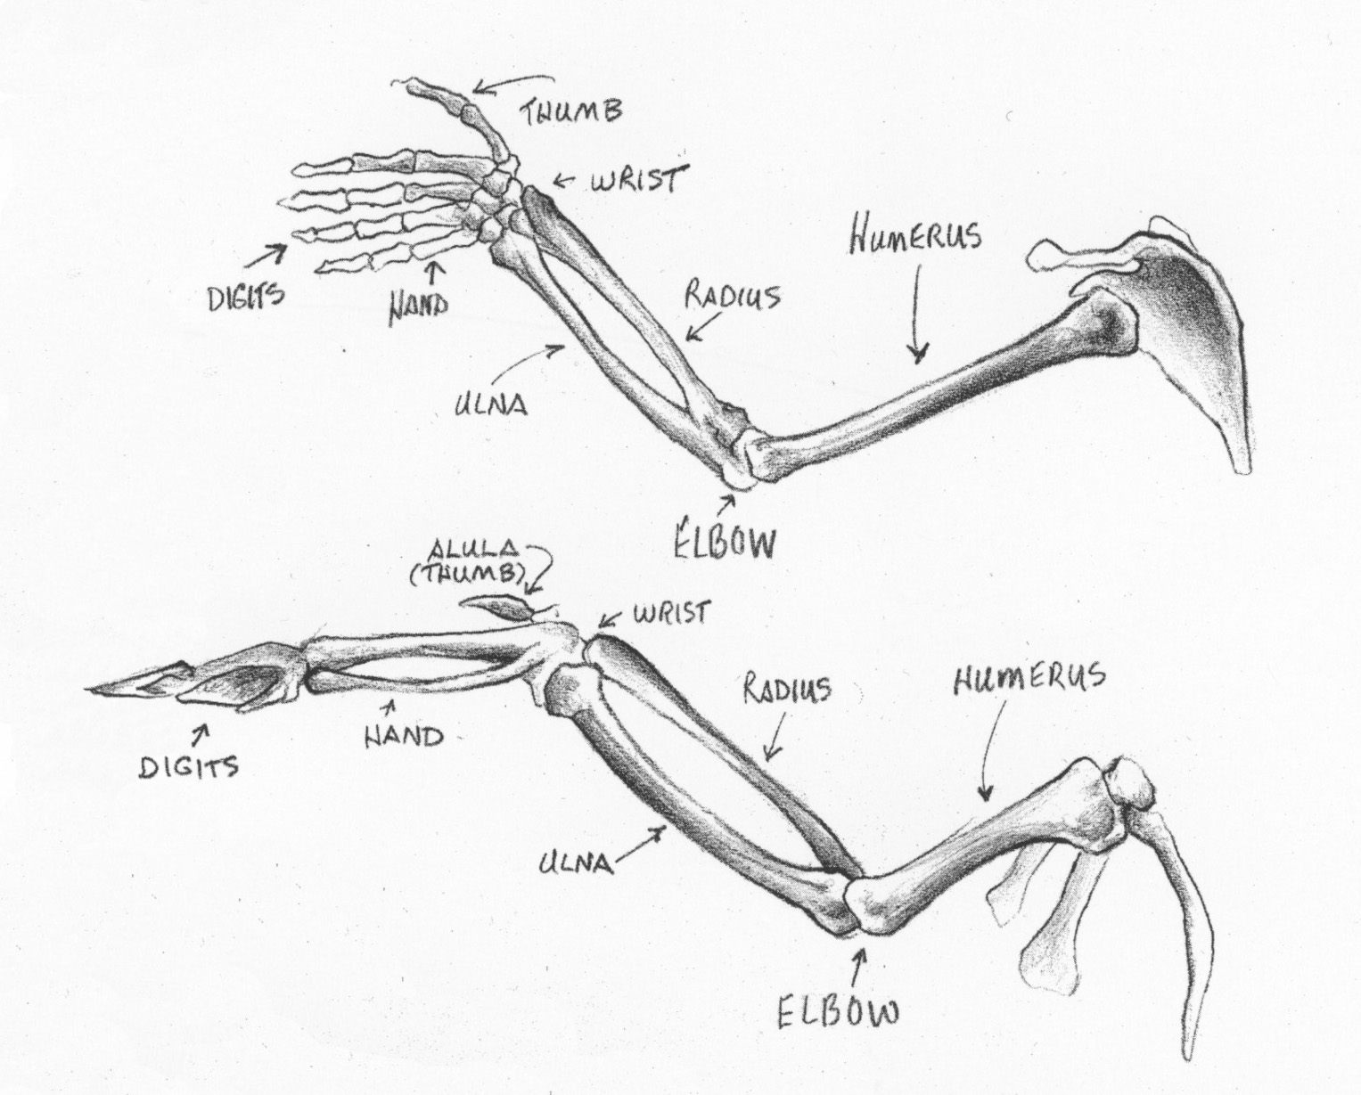

Chicken Wing Validation Name _______________________________________

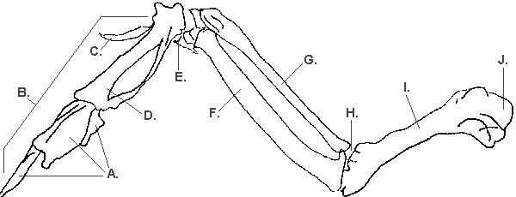

- List the names given to the analogous human bones for the following (3 marks)
f) _________________________________
g) _________________________________
i) _________________________________

- Which muscle would cause a increase in angle (extension) between bones I and G when it is contracted? _____________________________________ (1 mark)
- Name the type of joint and describe the range of motion of the following joints: (4 marks)
h) _____________________________________________________________________________
j) ______________________________________________________________________________
- Mark and label on the diagram above the origin and insertion of the bicep. (2 marks)

Name ____________________________

Participates fully
Care and respect for the specimen
Use of tools appropriately and carefully
Prepares microscope slide correctly
Follows instructions, cleans up properly

/5

Dissection booklet answers (group) /10
Participation checklist /5
Validation /10

Total /25

Draw and label diagrams of each of the 4 tissue types from under the microscope
(2 marks)

